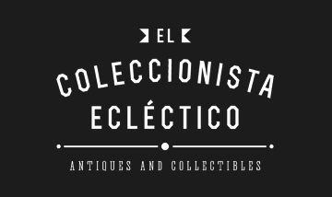

Withdrawal form
Complete and forward this form only if you wish to exercise your right of withdrawal in relation to the contract.

To:
El Coleccionista Ecléctico
Oscar Alonso Gallego
NIF: 11956894E
Paseo Zorrilla, 96, 2D
47006 Valladolid
España

Telephone: +34 606 45 40 99
E-mail: pedidos@elcoleccionistaeclectico.com

Hereby I would like to inform you that I wish to exercise the right of withdrawal in relation to my contract for the sale of the following goods:

Date purchased: ________________________________________

Order number: ________________________________________

Consumer name: ________________________________________

Consumer address:

Street / No: _____________________________ ________

Zip code / Municipality: ________ ___________________________

Country: ________________________________________

Consumer signature [Note. Only if this form is notified in writing]
_______________________________________________________

Date: ________________________________________

